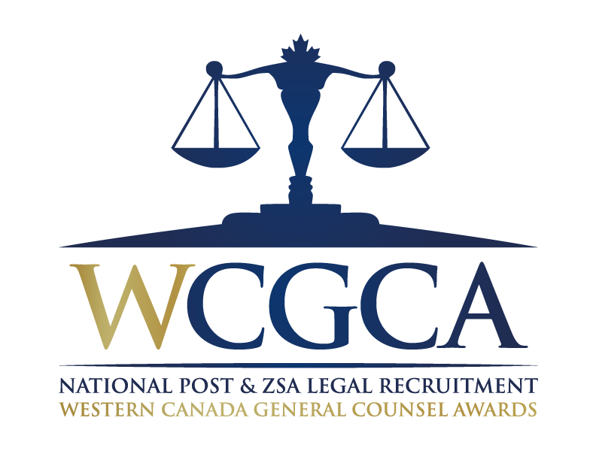
Western Canadian General Counsel of the Year Award Nomination Form
Conseiller juridique de l’année

ELIGIBILITY: The General Counsel or Chief Legal Officer only.

In selecting the Western Canadian General Counsel of the Year, our judges look for excellence, the ability to deal with complexity across both issues and jurisdictions and, an irrefutable sure-handedness in dealing with whatever challenges are faced.

In choosing one person to be honoured above all others, our judging panel looks most carefully at the role each candidate played in their company's overall health and well-being. Our Western Canadian General Counsel of the Year winner represents the very best of what this profession stands for.

The submission should explain how this nominee distinguished him/herself in terms of expertise; industry and in the broader community at large.

NOMINATOR:

NAME:
TITLE:
CORPORATION:
EMAIL:
TELEPHONE:
RELATIONSHIP TO NOMINEE:

NOMINEE:

NAME:
TITLE:
CORPORATION:
EMAIL:
TELEPHONE:
YEAR CALLED TO THE BAR:

Previous Award Recipients:

2017 – Harry Andersen, Pembina Pipeline Corp.

2015 – Charlene Ripley, Goldcorp Inc.

2013 – Alan O’Brien, Nexen

2011 – Peter Rozee, Teck Resources Ltd.
2009 – Terence Hopwood, Suncor Energy Inc.

Please ensure you address the following areas in your nomination:
- Description of nominee’s role
- Description of nominee’s company/division
- Nominee’s accomplishments/transactions this past year
- Awards/Recognition

DESCRIPTION OF NOMINEE’S ROLE:

DESCRIPTION OF NOMINEE’S COMPANY:

NOMINEE’S ACCOMPLISHMENTS/TRANSACTIONS:

AWARDS/RECOGNITION:

